**資料庫管理**

**SQL in-class Exercise** 

1. **Please use PostgreSQL.**
2. **Please import Employee_c.csv, Project_c.csv, Works_On_c.csv data.**
3. **Task 1: please copy and paste your codes.**
4. **Task 2 to 4: please copy and paste both your codes and the screenshot of results.**

Consider the COMPANY relational database schema and take a look at the three csv files.

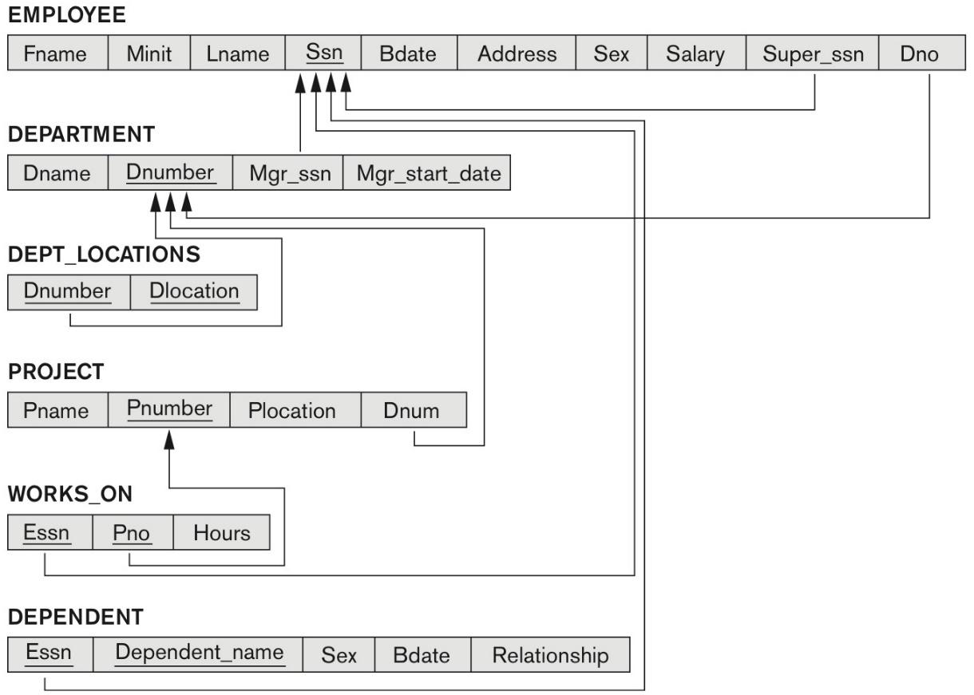

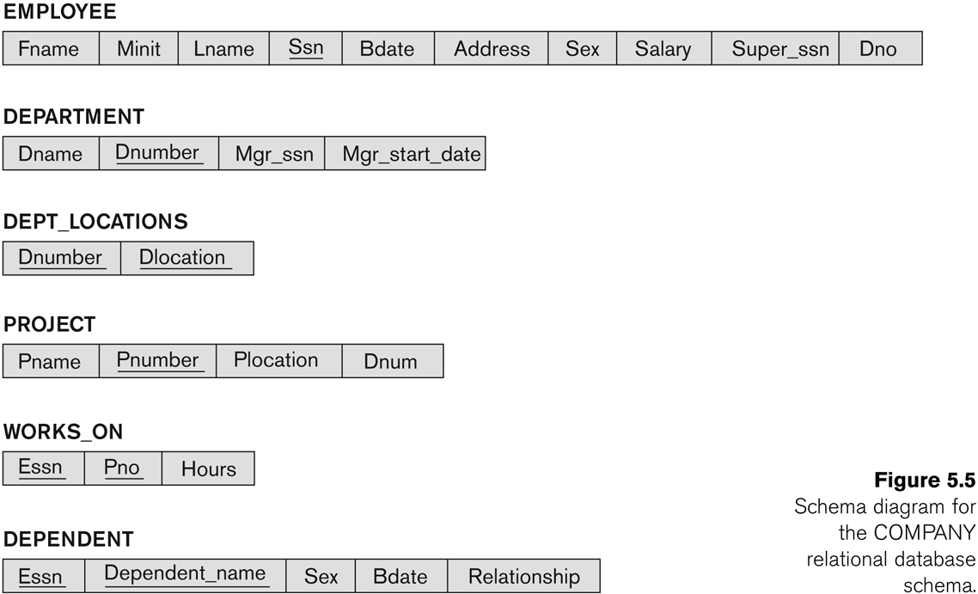



Task 1: Create three tables according to the COMPANY relational database schema (30 points).

Note: (1) If a supervisor quit his/her job, the supervisee’s supervisor will be set NULL.

(2) If a project is canceled, all the data related to the project in Works_on are deleted directly.

ANS:

CREATE TABLE EMPLOYEE(

Fname VARCHAR(20),

Minit CHAR(1),

Lname VARCHAR(20),

Ssn CHAR(9) PRIMARY KEY,

Bdate date,

Address VARCHAR(40),

Sex CHAR(1),

Salary integer,

Super_ssn CHAR(9),

Dno smallint,

CONSTRAINT fk_Super_ssn FOREIGN KEY(Super_ssn) REFERENCES EMPLOYEE(Ssn) ON DELETE

SET

NULL

);

CREATE TABLE PROJECT(

Pname CHAR(20),

Pnumber smallint PRIMARY KEY,

Plocation VARCHAR(20),

Dnum smallint

);

CREATE TABLE WORKS_ON(

Essn CHAR(9),

Pno smallint,

Hours decimal,

CONSTRAINT fk_Pno FOREIGN KEY(Pno) REFERENCES PROJECT(Pnumber) ON DELETE CASCADE

);

COPY EMPLOYEE

FROM

'D:\projects\110-1-db-management\exercise1\data\Employee_c.csv' DELIMITER ',' CSV HEADER;

COPY PROJECT

FROM

'D:\projects\110-1-db-management\exercise1\data\Project_c.csv' DELIMITER ',' CSV HEADER;

COPY WORKS_ON

FROM

'D:\projects\110-1-db-management\exercise1\data\Works_On_c.csv' DELIMITER ',' CSV HEADER;

**Write SQL queries to achieve the following requirements. Note that no duplicates should be produced in any of the answers.**

Task 2: Get the names of all employees who are directly supervised by Franklin Wong (20 points).

ANS:

SELECT

E.Fname,

E.Lname

FROM

EMPLOYEE AS E,

EMPLOYEE AS S

WHERE

E.Super_ssn = S.Ssn

AND S.Fname = 'Franklin'

AND S.Lname = 'Wong';

Task 3: Get the names of all employees who only works on the project controlled by department 5 (20 points).

ANS:

SELECT E.Fname, E.Lname

FROM EMPLOYEE AS E

WHERE E.Ssn IN (

SELECT Essn

FROM WORKS_ON

WHERE Pno IN (

SELECT Pnumber

FROM PROJECT

WHERE Dnum = 5

)

EXCEPT(

SELECT Essn

FROM WORKS_ON

WHERE Pno IN (

SELECT Pnumber

FROM PROJECT

WHERE Dnum <> 5

)

)

);

Task 4: Get names of all employees in department 5 who work more than 10 hours/week on the ProductX project (30 points).

ANS:

SELECT E.Fname, E.Lname

FROM EMPLOYEE AS E

WHERE E.Ssn IN (

SELECT W.Essn

FROM WORKS_ON AS W, PROJECT AS P

WHERE P.Pname = 'ProductX'

AND P.Pnumber = W.Pno

AND W.Hours > 10

);